C64 Mechanical Keyboard & Kernal Switcher
3D Printables
Module Description

Introduction
The C64 Keyboard PCB requires either a mounting frame for screwing it into a C64 or C64C case or a USB keyboard case. All parts were designed to fit on a 3D printer with a 25cm wide print bed.
The mounting frame was tested with different cases, like the C64 Breadbin, different C64C cases and the C64C clip case.
There are two different versions of the C64 USB-keyboard:
- Classic for using the original keycaps and a classic 9U space bar
- Modern for modern keycaps (DIY and Blingboard64/C64U keycaps).
The difference are the plates.

The Mounting Frame
The mounting frame is attached to the C64 Keyboard PCB with 16 each C 2.2x6.5 H DIN 7981 self-tapping screws for sheet metal.
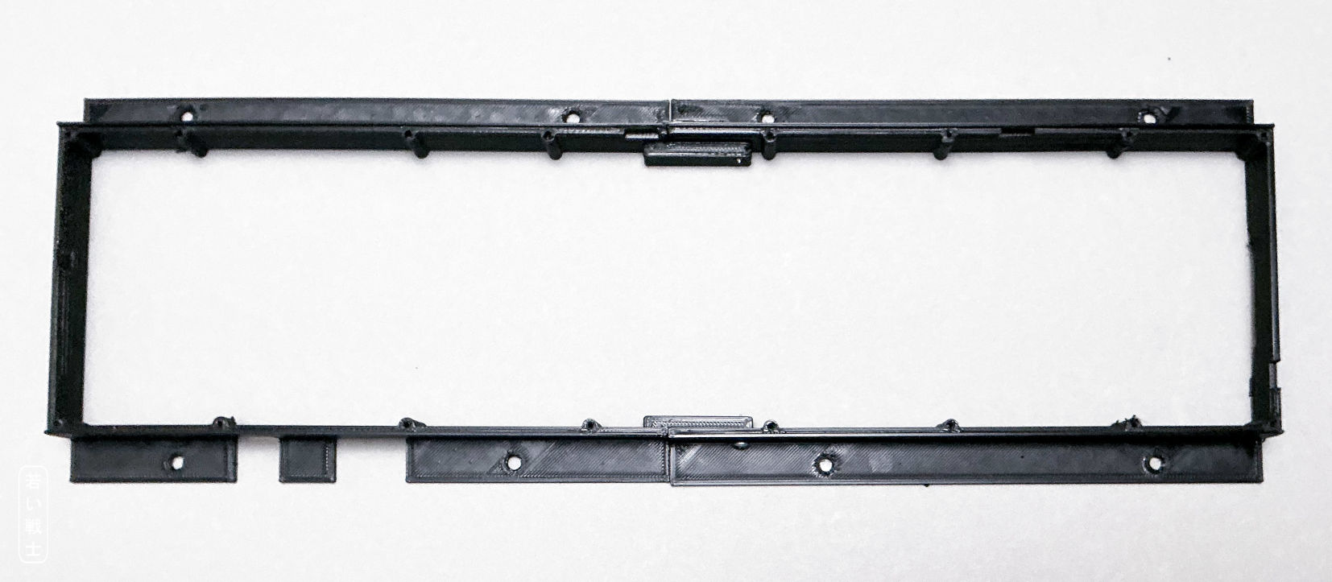
Figure 1: Mounting frame (Rev. 1)
For the PCB Rev. 0, a Rev. 0 mounting frame is required. For a PCB Rev. 1 and 2, a Rev. 1 mounting frame is required. The difference is, that Rev.1 is capable of a 9U stabilizer which causes one screw being moved right some millimeters.
A stiffener is an optional part. The purpose is to stiffen the PCB. It is mounted to the keyboard with 9 each C 2.2x6.5 H DIN 7981 self-tapping screws for sheet metal (Figure 4). In my experience, the stiffener is not required. It is identical for all PCB revisions.
There are two additional C 2.9x9.5 H DIN 7981 screws, which hold both sides of the frame together. They are screwed in at about the middle of the northern and the southern side, as shown in Figure 2.
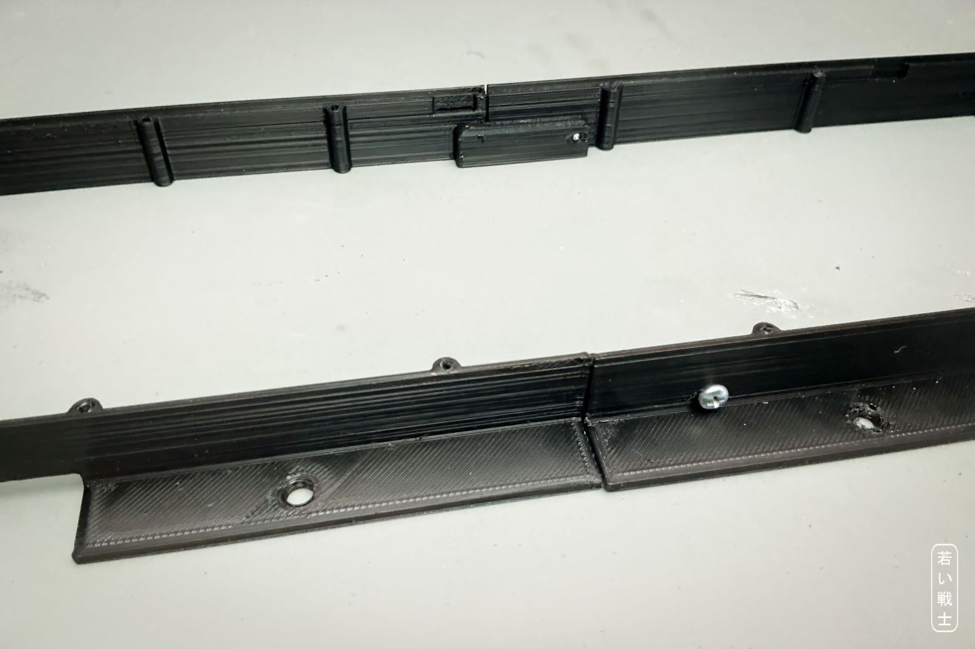
Figure 2: the two halves of the frame, joined by two horizontal screws
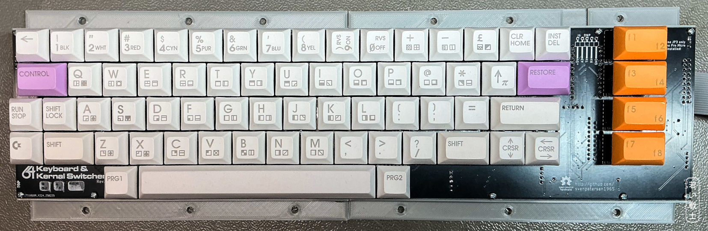
Figure 3: The keyboard PCB Rev. 0 mounted on a Rev. 0 frame
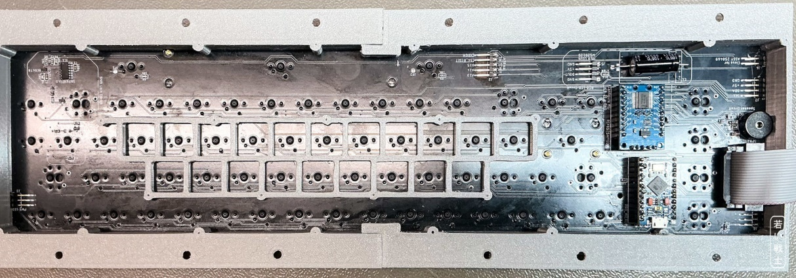
Figure 4: Keyboard with stiffener
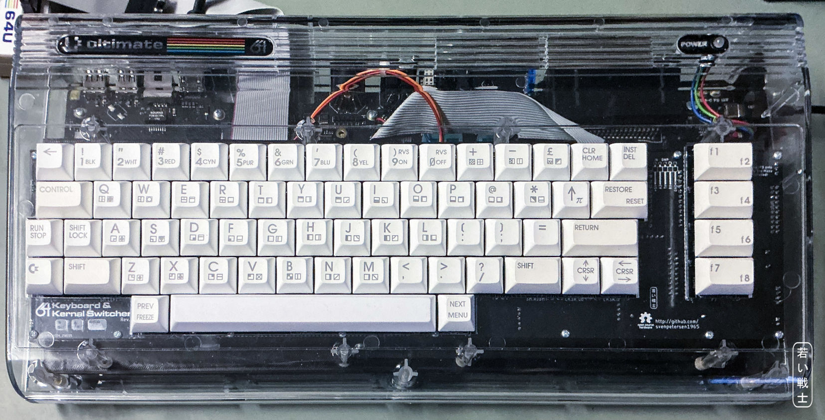
Figure 5: Keyboard mounted in a C64 breadbin case (clear, RetroFuzion)
The keycaps are standing out of the case in a clip case. The reason is, that the PCB has to touch the case. The height of the mounting frame is defined by the height of the clip. The height of the keycaps in a normal C64C case is absolutely acceptable.

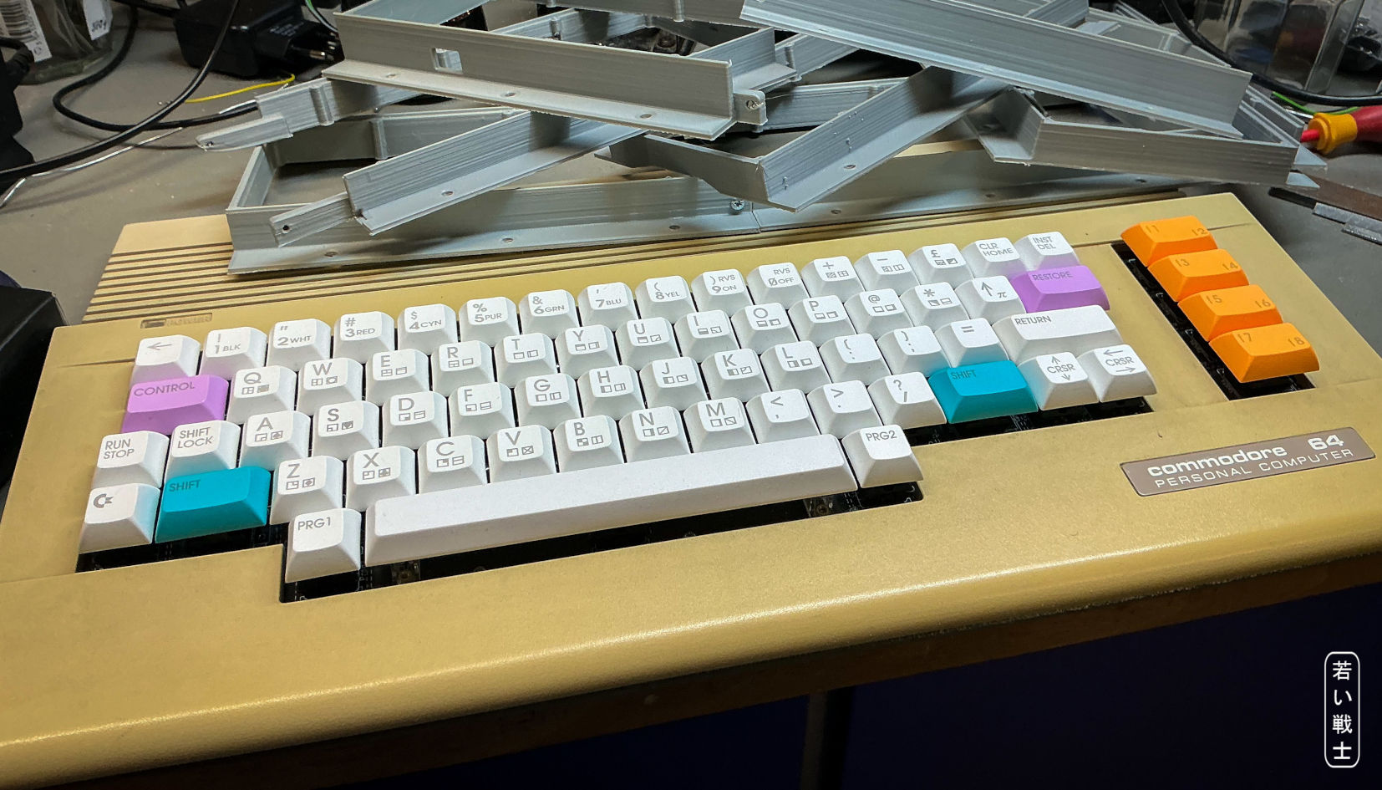
Figure 6: Keyboard in a C64C clip case
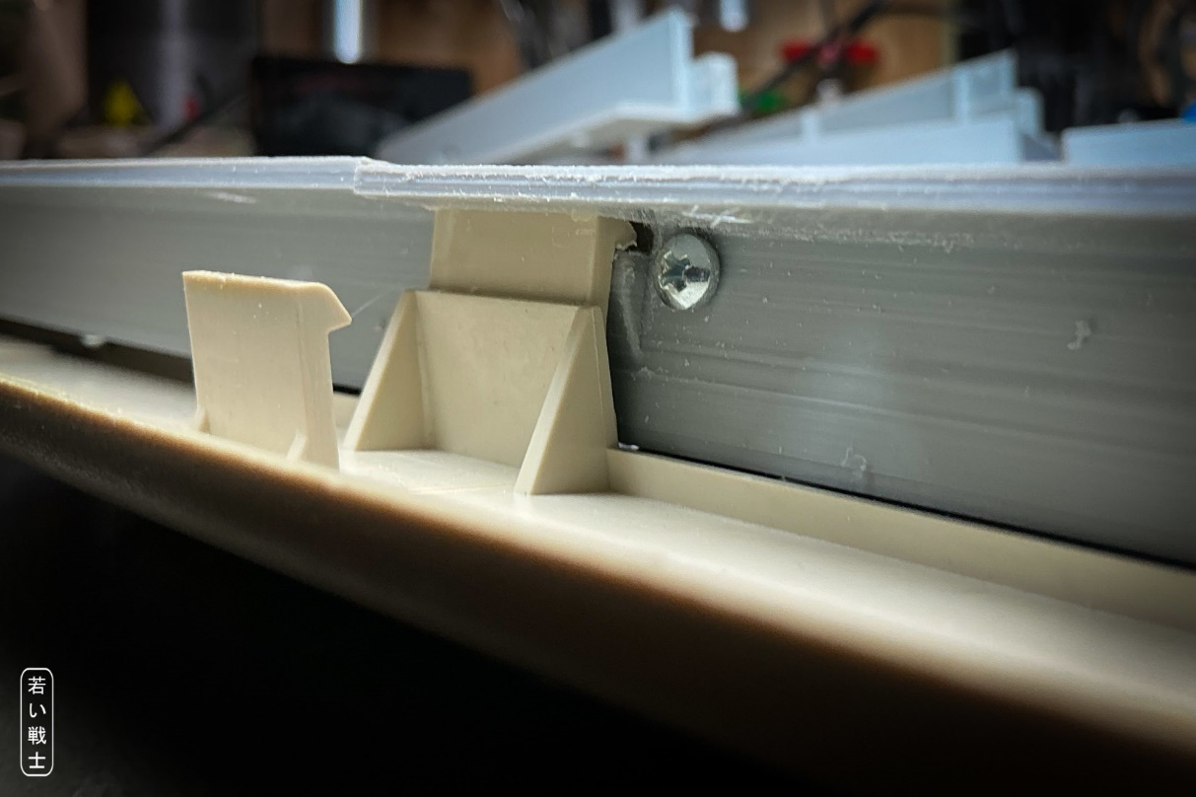
Figure 7: The clip case clip, the C 2.9x6.5 H screw
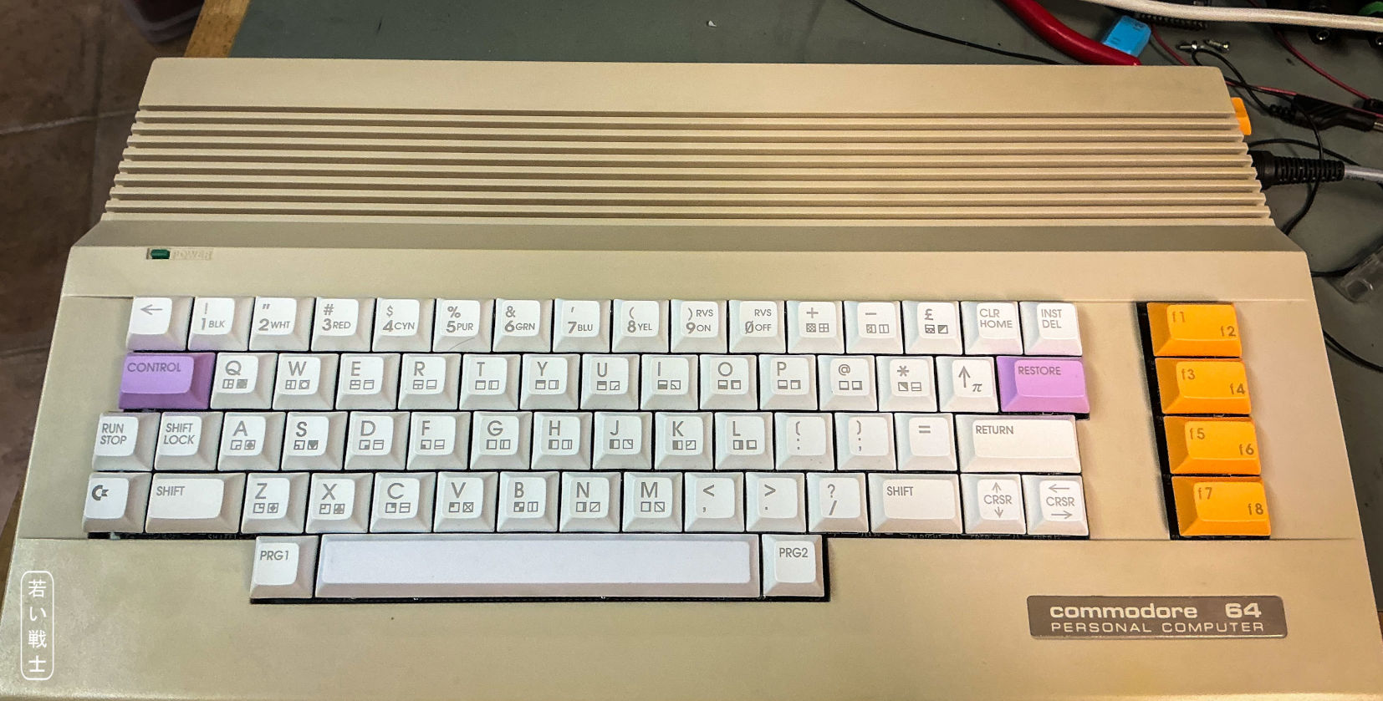
Figure 8: C64 keyboard in a normal C64C case

The C64 USB-Keyboard Case
The USB keyboard case consists of 7 different parts.
- The plate (standard or classic) – two halves
- The case – two halves
- The bottom – 3 parts
The plate is a level 5mm elevated above the PCB. It has cutouts for the keyboard switches. Since it should fit on an average 3D printed, it is printed in two parts. There are two versions:
- Standard: all 1.5U switches populated in SW**A positions, 7U stabilizer
- Classic: all 1.5U switches populated in SW** positions, 9U stabilizer
The case is divided into two halves for the said reasons.
The bottom is divided into three parts. The middle part spans over both case halves to add some stability.
They USB-keyboard case requires 42 each C 2.2x6.5 H DIN 7981 self-tapping screws for sheet metal:
- 16 for the PCB
- 14 for the plate
- 12 for the bottom
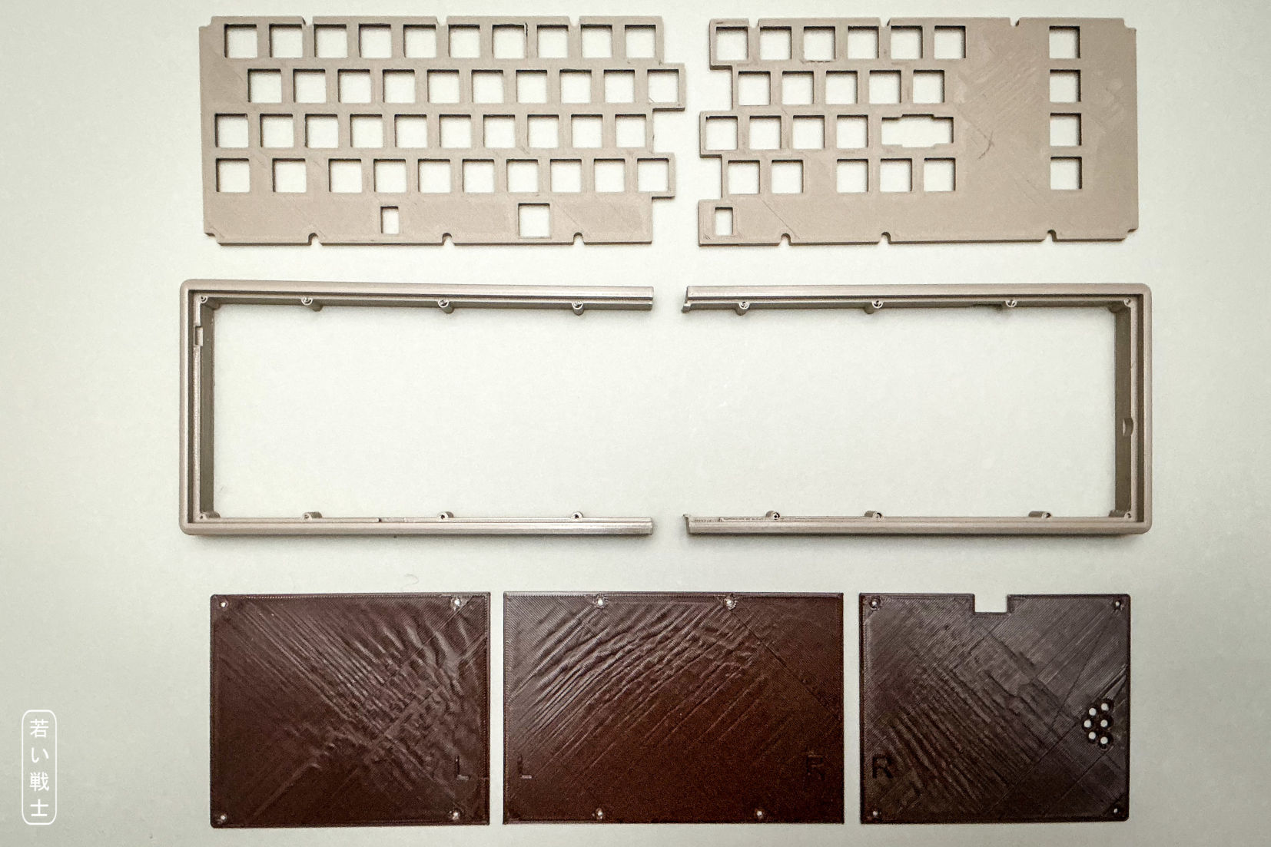
Figure 9: USB-Keyboard case parts: plate (top), case (mid), bottom (bottom)
It is important, that the plates are properly de-burred, before they are installed. They are already a bit wider, than the standard measures, since cutouts tend to be less wide, than constructed in 3D printing. Not de-burring them could result in high forces being required for installing the switches, in not properly seated switches (especially on hot swap sockets) and damaged hot swap sockets (happened to me).
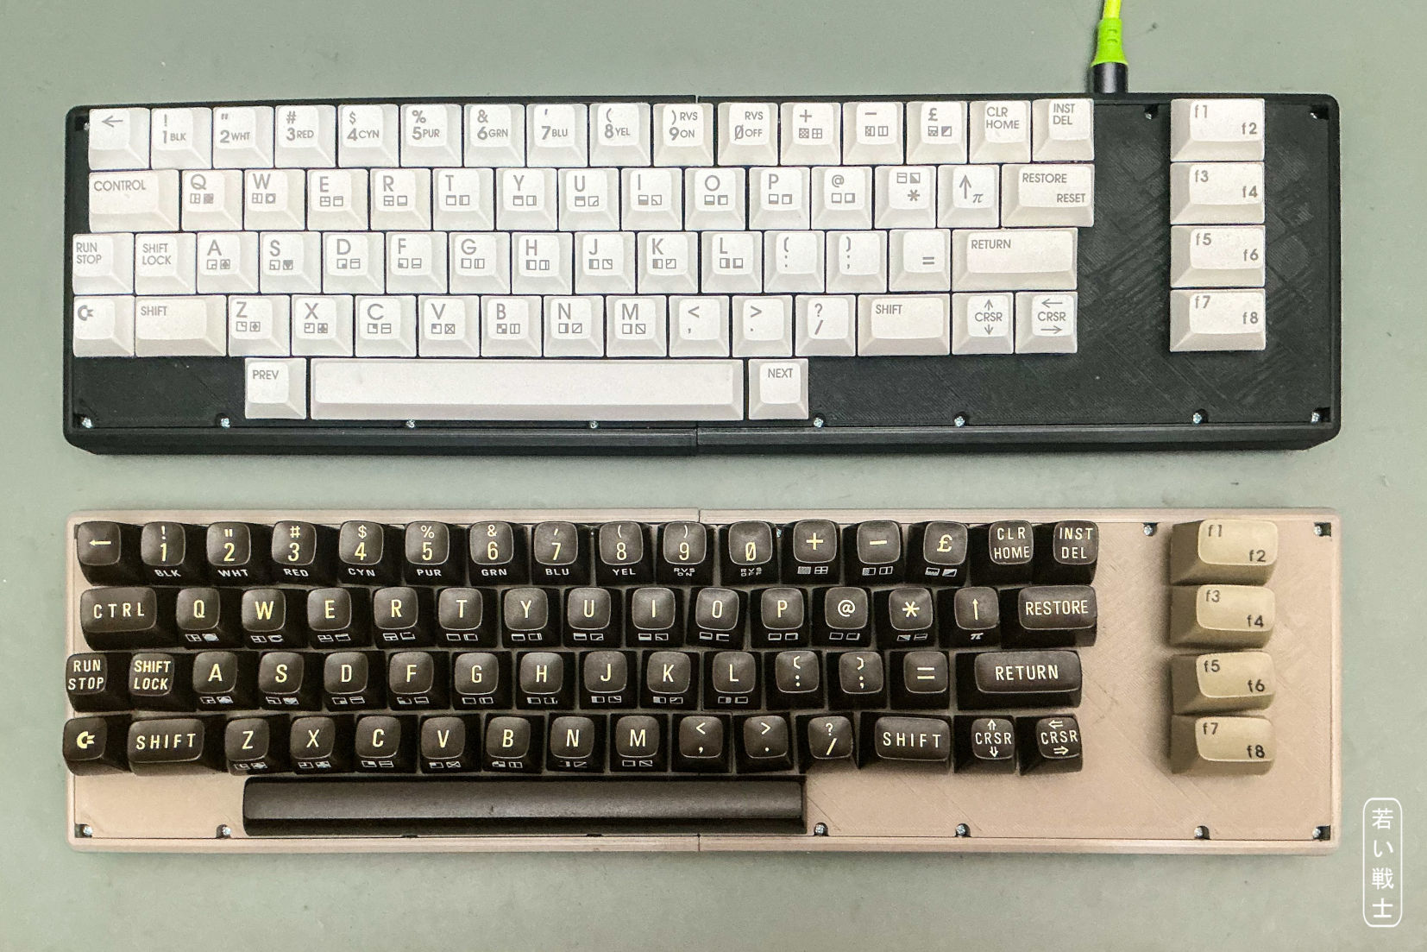
Figure 10: standard (top) and classic (bottom) USB-keyboard case
The plates would also fit with the mounting frame, if desired. They are made for PCB Rev. 1 and 2. They are using the same mounting holes of the PCB like the stiffener (plus holes added in PCB Rev. 1).
Note: Figure 10 shows a keyboard, that was constructed with the recalled keycap adapters, that were not properly aligned, which is visible on the bottom keyboard. They were immediately replaced by Retro Fuzion with perfect keycap adapters. They are installed in a Ultimate 64 and I didn’t want to transplant them for the picture. Fresh keycap adapters are on their way from Australia.

